1. **Control algorithm for caustic shock dosing in sewers**

* 1. **Background**

A drastic pH rise (10-12) allows the suppression of SRB and MA, responsible for sulfide and methane production, respectively. To maintain low production of sulfide, pH shock has to be applied regularly (e.g. weekly)

|  |
| --- |
| Further information can be obtained as follows:   * Effects of caustic shock dosing:   + **Paper:** *O'Gorman, J., Purssell, I. and Iori, G. (2011) Caustic soda washing of a sewer pressure main - Cost-effective removal of biofilm that reduced both odour and methane. Water 38(1), 83-87.*   + **Paper:** *Gutierrez, O., Park, D., Sharma, K.R. and Yuan, Z. (2009) Effects of long-term pH elevation on the sulfate-reducing and methanogenic activities of anaerobic sewer biofilms. Water Research 43(9), 2549-2557.* |

* 1. **Control Strategy**
     1. **Dosing Location**

To be effective, this chemical should be dosed at the beginning of the pipe to ensure SRB suppression in the whole pipe.

* + 1. **Dosing rate**

Caustic shock aims to increase the pH of the sewage to high levels (pH 10-12) during a short time period. Dosing requirements depend basically on sewage pH, buffer capacity of the wastewater and the desired pH set-point to be reached.

Sewage pH is very dynamic throughout the day, but can be easily monitored on-line using common and inexpensive sensors. Buffer capacity of the wastewater needs to be determined by titration.

* + 1. **Exposure time**

Dosing duration to reach certain exposure time needs to be properly timed and will depend on future flows, requiring HRT prediction.

* + 1. **Frequency**

The use of on-line sensors such as S::CAN or Odalog will allow to monitor the recovery of SRB activity and the dosing frequency can be adjusted accordingly.

* + 1. **Dosing scheme**

The control algorithm for the optimised dosing of NaOH for caustic shock will be composed of a feedforward and a feedback loop. This will allow achieving the required pH in the wet well. Flow measurements will be used to predict future flow and determine dosing duration to ensure a suitable exposure time. Finally, dosing frequency will be controlled using an OdaLog/S::CAN sensor at discharge.

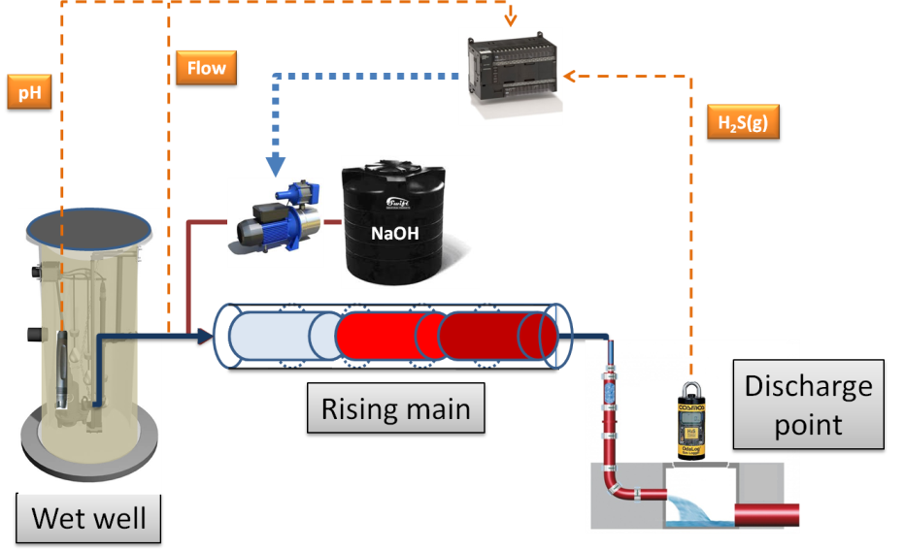

Figure 1. Control algorithm scheme for caustic shock.

* 1. **Case studies**